**The exec Function**

**LAB # 04**



**Fall 2022**

**CSE302L System Programming Lab**

Submitted by: **Maaz Habib**

Registration No. : **20PWCSE1952**

Class Section: **C**

“On my honor, as student of University of Engineering and Technology, I have neither given nor received unauthorized assistance on this academic work.” Student Signature: ______________

Submitted to:

**Engr. Abdullah Hamid**

Saturday, November 5th, 2022

**Department of Computer Systems Engineering**

**University of Engineering and Technology, Peshawar**

**Lab Objective(s):**

• Understand and implement exec Function.

**Task # 01:**

**Write a program that takes N UNIX commands as arguments, creates N child processes, each of them implementing their respective commands.**

**Code:**

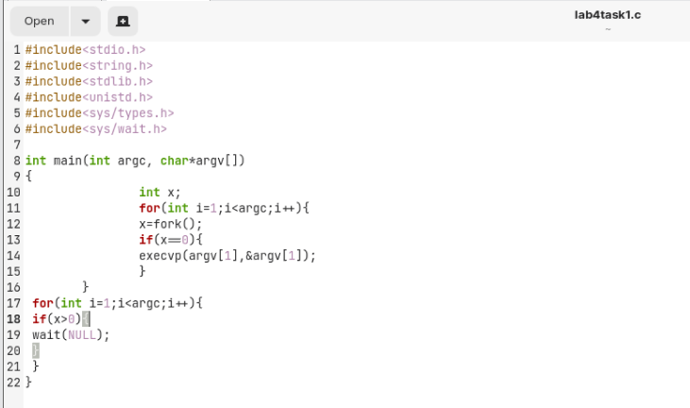

**Output / Graphs / Plots / Results:**

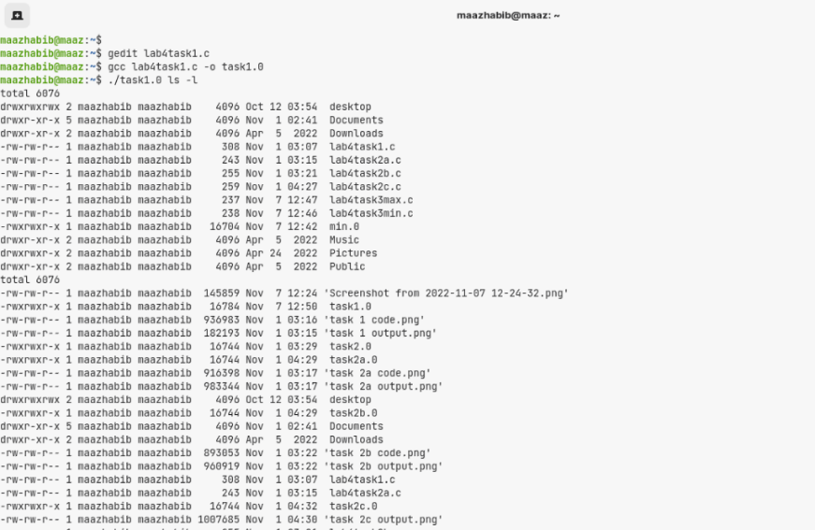

**Task # 02:**

1. **Write a program that takes integers as arguments and adds them.**
2. **Write a program that takes integers as arguments and multiplies them.**
3. **Write a program that takes integers as arguments & adds & multiplies them using the above two programs.**

**Task 2.a:**

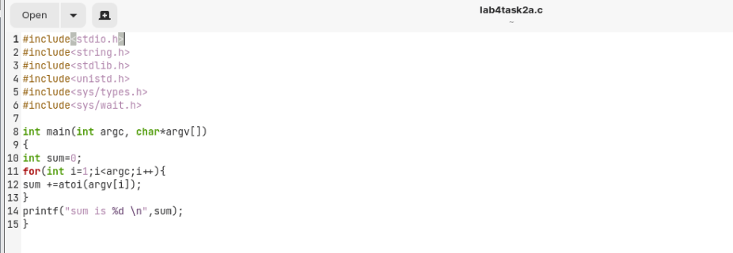

**Output:**

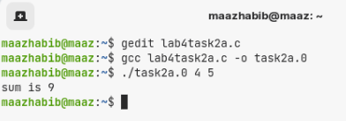

**Task 2.b:**

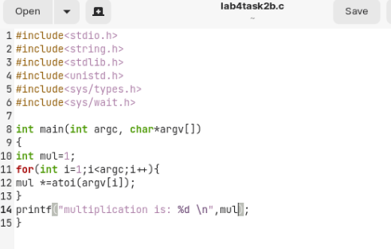

**Output:**

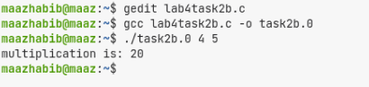

**Task 2.c:**

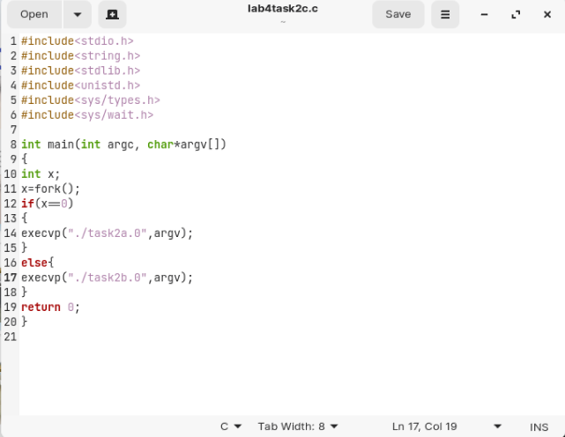

**Output:**

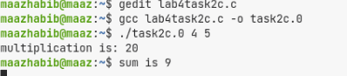

**Task 3:**

**Write a program “minmax.c” that takes an array as command line arguments. Program executes min.c and max.c programs in its two child processes. One child processes calculates and returns the min value and other calculates and returns the max value in the array. The program “minmax.c” shall receive the values returned by the child processes and display these values.**

**Min:**

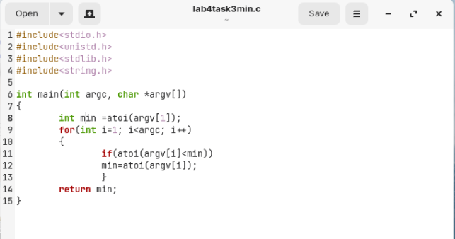

**Max:**

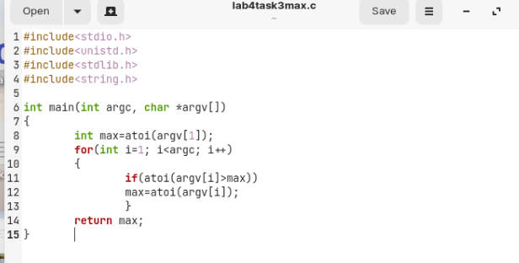

**Minmax:**

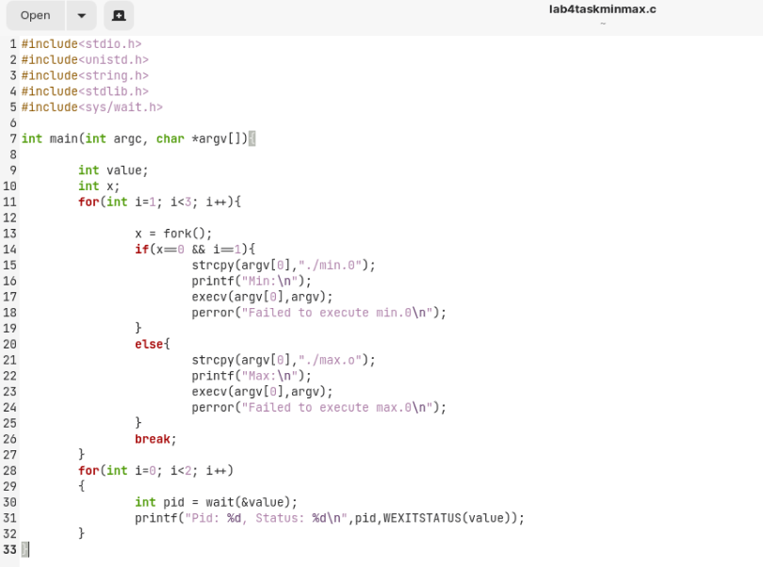

**Output:**

